LOESS INTEGRATED LEARNING SCENARIO
Introduction
In LOESS, the acquisition of soil health knowledge is facilitated using integrated STEM teaching and learning, which is carried out via the Biology Science Curriculum Study (BSCS) 5E Instructional Model by Bybee and colleagues (Bybee et al. 2006) as well as the application of innovative pedagogical approaches (PBL, IBL, etc).

Keywords
Soil properties, fertility, sustainable management practices, Geographic Information Systems (GIS) applications

Title
Soil Detectives

Authors
Ana Belén Yuste Martínez & Javier Calamardo Murat

Summary
This learning scenario analyses different soil properties (moisture, organic matter content and nutrient retention), invites students to use the acquired knowledge to analyse fertility and sustainable practices developed in the local community. Similarly, it combines practical analysis in the laboratory with theoretical content on the importance of soil and invites students to capture all the results obtained in a GIS that maps the area. Finally, the content learned will be presented in a dedicated song, promoting creativity and the responsible use of artificial intelligence.

Licenses
Attribution ShareAlike 4.0 International (CC BY-SA 4.0). This license lets others copy and redistribute the material in any medium or format for any purpose, even commercially; it also allows to remix, transform, and build upon the material for any purpose, even commercially. The licensor cannot revoke these freedoms as long as the license terms are followed.

Subject (s)
Biology, Geography, Geology

Real-life questions
- How do soil properties influence the development of vegetation and life on Earth?
- What factors threaten soil fertility, and how can we determine if soil is fertile?
- What characteristics must soil have to be considered fertile?
- How can we evaluate and compare soil fertility in different areas?
- What practices, such as regenerative agriculture, can help maintain or restore soil fertility?

Learning objectives
- Learn how to look for useful information online.
- Engage students in multidisciplinary activities.
- Represent information in Geographic Information Systems (GIS).
- Enrich students’ vocabulary with words relevant to soil education.
- Develop critical thinking and work collaboratively conducting soil analysis.
- Create awareness on the factors that threaten soil fertility and learn how to assess soil health and fertility.

Link to curriculum
The learning scenario fosters the acquisition of knowledge and interaction with the physical world (STEM Competence), which is developed through soil analysis and assessment. It also enhances digital skills by incorporating GIS technology for mapping and data analysis (Digital Competence). Furthermore, it fosters environmental awareness and sustainability by exploring soil health and sustainable agricultural practices, aligning with the curriculum's focus on environmental education (Citizenship Competence).
These topics are relevant across different educational systems and align with global Sustainable Development Goals (SDGs), such as Goal 12 (Responsible consumption and production) and Goal 15 (Life on Land). The methodology is flexible, allowing for adaptation to various local contexts and educational resources. The principles of analysing soil health and employing technology can be tailored to fit different soil types, environmental issues, and available tools, making the learning scenario applicable worldwide.

Age of students
Between 14 and 16 years old.

Time
Preparation time: 3 hours.
  - Geography (1 h).
  - Biology & Geology (2 h).
Teaching time: 5 sessions (55 minutes each one).
  - Geography (3 sessions).
  - Biology & Geology (2 sessions).

Teaching resources (materials & online tools)
Materials:
Material for all lessons
  - Computers/tablets.
  - Internet connection.
Materials for Lesson 2
- Annex 2 - Data sheet latex gloves or similar, zip bags, ruler, small shovel, markers.
Materials for Lesson 3
- Moisture: Petri dishes or watch glasses, laboratory scale, stove or oven.
- Organic matter: Petri dishes or watch glasses, laboratory scale, hydrogen peroxide.
- Nutrient retention: a funnel, a beaker, filter paper, 100 ml 0.4N copper sulphate (CuSO₄) solution.
Online tools:
Lesson 1. Brainstorming and discussion
- Why soil is one of the most amazing things on Earth (BBC video)
https://www.youtube.com/watch?v=OiLITHMVcRw
- A short video on the importance of soil can be used as an alternative to the video above
https://www.youtube.com/watch?v=UEpbK9qPj-s
Lesson 2. Preparation for next lesson
- Website of the Spanish Society of Soil Science
The website showcases soil properties and offers a soil exercise
https://www.cienciadelsuelo.es
- Food and Agriculture Organisation (FAO) soils portal
Can be used as an alternative to the website above as it also showcases soil properties
https://www.fao.org/soils-portal/en/
Lesson 2. Soil and SDGs
- Soil and SDGs infographic (see link below or Annex 3 – SDGs and soil)
https://openknowledge.fao.org/items/456f7cf7-8bab-441c-a0b3-15a9d68a6773
Lesson 2. Virtual exploration
- A website that showcases satellite images of the Earth
Option 1 EarthExplorer https://earthexplorer.usgs.gov/
Option 2 Google Earth https://earth.google.com/web/
Option 3 INPE http://www.dgi.inpe.br/catalogo/explore
Lesson 3. Discussion
- Video on regenerative agriculture
Option 1 https://www.youtube.com/watch?v=fSEtiixgRJI
Option 2 https://www.youtube.com/watch?v=_0yn74At4ks
Lesson 5. Learning products
- Google MyMaps
https://www.google.es/maps/
- Bing Maps
https://www.bing.com/maps
Lesson 5. Interpretation of data and conclusions
- ChatGPT
A generative artificial intelligence chatbot
https://chatgpt.com/
- SUNO
A generative artificial intelligence music creation program
https://suno.com/

STEM Strategy Criteria
Developing the LOESS learning scenario will help you and your school comply with the STEM School Label criteria. Please find below which STEM School Label criteria this learning scenario fulfils.
Elements and criteria | How is this criterion addressed in the learning scenario?
Instruction
Personalisation of learning | Students will analyse the soil of their own local community or neighbourhood.
Problem and project-based learning (PBL) | Students will address the problem of loss of soil fertility.
Inquiry-Based Science Education (IBSE) | Students will analyse several fundamental parameters for soil fertility, investigating and concluding on the status of the soils analysed in their location.
Curriculum implementation | In this learning scenario, STEM (Biology, Geology) and non-STEM subjects (Geography), key competencies and the SDGs are worked on together.
Emphasis on STEM topics and competencies
Interdisciplinary instruction | Examining and implementing a variety of activities by connecting Geography with Biology and Geology.
Contextualisation of STEM teaching | Science is conducted in the laboratory when analysing various soil parameters. Technology and Engineering are carried out in the development of maps via the Geographic Information Systems while Mathematics is carried out via calculations when analysing parameters.
Assessment
Continuous assessment | Throughout the learning scenario, the student's teamwork in the laboratory and in the preparation of maps is valued.
Professionalization of staff
Highly qualified professionals | The different sessions are taught by specialists in each subject (Biology, Geology and Geography).
School leadership and culture
High level of cooperation among staff | Good coordination between teachers of different subjects is necessary for the correct development of learning scenario.
School infrastructure
Access to technology and equipment | The materials needed for the development of this learning scenario are cheap and easy to find. As for technological resources, they are also open, and their use is easy to understand.
High quality instruction classroom materials | This learning scenario represents an innovative activity that combines scientific knowledge and skills with the technological development of geographic information, interconnecting different subjects.

Description of activities
Name of activity | Procedure | Time
1st Lesson
5E Phase | Engage
Subject | Geography
Brainstorming and discussion | As an introduction, a BBC video which explains the importance of soil in our lives will be shown. What is sought with this is to awaken the environmental awareness of students about the edaphic problems that our planet suffers and, especially, about the loss of fertility due to different factors.  Brainstorming session that will be carried out to find out what the students know about the properties of the soil and its influence on the development of the vegetation cover. Brainstorming will be supported by the following questions:  - What are the main components of soil?  - What role does organic matter play in soil fertility?  - How important is soil biodiversity for ecosystems?  - How can agricultural practices affect soil health and the vegetation that grows on it? | 25 minutes
Preparation for the next lesson | To learn the basic concepts that students need to know about soil and deepen their understanding about soil, the interactive Edafos program will be used i.e., a e-learning resource that provides a comprehensive review of the fundamental concepts and processes of soil science. The Edafos program is accessible from the website of the Spanish Society of Soil Science and is available in English and Spanish.  Students, in groups of four, will visit the website and find information about the concept of soil profile, its components, its formation and its functions. If there is time, the students can try the exercise with 24 questions available on the platform. As an alternative to the Edafos program, students can also use the FAO soils portal. | 30 minutes
2nd Lesson
5E Phase | Engage
Subject | Biology and Geology
Soil and SDGs | The teacher asks the students Why soils are important? and writes it on the board. Then, the teacher shows this infographic (also in Annex 3 – SDGs and soil) that relates the importance of soil to the SDGs with the students. More questions can be asked to introduce the SDGs e.g.: How can soil quality and its sustainable use influence poverty reduction? How can soil conservation contribute to improving food security and combating world hunger? How can soil degradation affect human health? How does soil management influence water quality and access to drinking water in communities? Why is sustainable land management important to ensure responsible production and consumption? How can proper soil management help mitigate the effects of climate change? Why is it crucial to conserve soils to protect biodiversity? | 10  minutes
Keep soil alive! | After analysing the importance of soil, students should know that not all soils can provide us with these benefits, due to their current state (erosion and loss of fertility). This is intended to raise awareness among students about the importance of taking care of the soil. Finally, the teacher asks the students: What do you think the soil of our town is like? Still fertile? What do we use it for? | 10  minutes
Virtual exploration | In groups of four, students explore satellite images of the Earth (e.g., using EarthExplorer, Google Earth or INPE) to know if the soil in their locality is fertile (there is vegetation cover, crops...). They discuss the findings and with these images alone, it is enough to know if the soil can support vegetation. | 20  minutes
Our soil | In this last part, the parameters of the soil will be analysed in the laboratory. The teacher asks the students: What characteristics does a soil have to be fertile? Teacher then writes them on the board, while students are expected to say organic matter, microorganisms, moisture, nutrient retention, etc.  The teacher proposes to analyse these parameters in local soils to truly know if they retain their fertility or not. Groups of four students are formed. Each group is assigned a city area and surroundings to take a soil sample and be able to analyse it in the laboratory or in the classroom. Students could contact local farms or organizations which could be a great way to access a wider variety of soil samples.  The teacher explains how the sample collection should be carried out (Annex 1 – Soil sampling) and gives each group a sheet to fill in (Annex 2 - Data sheet). | 15 minutes
3rd Lesson
5E Phase | Explore
Subject | Biology and Geology
Moisture | Each group will calculate the moisture content of their soil, an important factor to determinate its fertility. Take a container (Petri dish, watch glass...) and write down the weight of the empty container (C) and add between 10 and 30 grams of soil. Weigh it, to calculate the weight of the wet soil (W soil). The sample is then placed in the oven or stove at 105 °C for 24 hours (Annex 7 – Experiments). | 15  minutes
Organic matter | Each group will analyse the organic matter content of their soil sample. Each group takes a soil sample (approximately 10 grams), and places it, for example, on a Petri dish or a watch glass. Next, a few drops of hydrogen peroxide are applied. If the soil has high organic content, effervescence will occur, a fact that does not occur if the soil is poor in organic matter. The chemical reaction that produces effervescence is due to the presence of catalase in the soil. Catalase is an enzyme found in the cells of animal and plant tissues.  Depending on the bubbling observed, the organic matter content will be determined as: poor (no bubbling), moderate (slight bubbling) or high (intense effervescence and/or foam). See Annex 7 – Experiments. | 15  minutes
Nutrient retention | Each group will analyse the nutrient retention of their soil, another important factor to determinate its fertility. Each group takes a funnel, a beaker and filter paper (conic or a coffee filter). Place the filter paper in the funnel and fill it with soil. Add 100 ml of 0.4N copper sulphate CuSO₄ solution (Annex 7 – Experiments).  Observe the colour of the filtered solution. The more transparent it is, it means that it has a greater capacity to retain nutrients. The colour of the solution obtained may vary from the original blue due to its mixture with other chemical elements. | 25  minutes
4th Lesson
5E Phase | Explore, explain and elaborate
Subject | Geography
Moisture II | Each group takes its sample out of the oven or stove, lets it cool, and weighs it again. Calculate the % moisture of their soil using the formula on the data sheet (Annex 2 - Data sheet). | 10  minutes
Discussion | Share the results obtained. Reflect on whether the soils in our town are fertile or not, and what could be done to maintain and/or recover that fertility. The teacher talks to them about regenerative agriculture with a video (option 1, option 2).  Description of video 1: Regenerative agriculture is an effective way to restore biodiversity and stabilize the climate, but what exactly is it? This video explores three different regenerative practices that have great potential both in food production and in healing the land.  Description of video 2: Regenerative agriculture can help us fight the impacts of climate change while restoring ecosystems, water and carbon cycles, and spurring economic growth. But what is regenerative agriculture? NRDC wanted to learn more from the farmers and ranchers doing the work, so we interviewed 113 growers, and they told us what regenerative agriculture means to them. We learned that regenerative agriculture goes beyond farming practices. Produced in collaboration with Kiss the Ground, this video summarizes what regenerative agriculture is, as told by the farmers and ranchers we interviewed. | 15  minutes
Dumping of data I | Once the necessary experiments have been carried out and all the parameters of the different soil samples have been collected, students (in groups of four) reflect on the characteristics of each soil studied on an interactive maps tool (e.g., MyMaps or Bing), used like a Geographic Information System (GIS). With that tool we can work with georeferenced information, process, analyse and represent spatial data.  Previously, the teacher prepares the map with one layer call “moisture”. Each group has to put a pin in the coordinates where they collected the soil. They write there about the moisture of their soil and describe the soil. Finally, they add a photo of the area. They have to set the pin to red, yellow or green depending on the data obtained (green high moisture, yellow medium moisture and red low moisture).  The teacher creates another two layers: nutrients retention and organic matter. The procedure is the same in each layer. The students create a pin close to the previous one, choose the colour appropriate to their results, write them and copy the same description of the soil and upload the photo. | 30  minutes
Learning products | An interactive map (GIS). It is recommended to display it on a digital map (e.g. Google MyMaps).
5th Lesson
5E Phase | Elaborate and evaluate
Subject 5 | Geography
Dumping of data II | Finalize the interactive and collaborative map (if needed). | 15 minutes
Interpretation of data and conclusions | The last session will be dedicated to finish data introduction (if needed) and to the interpretation of the data obtained by sharing from the different groups of students. Through the comparative analysis of the samples studied, the students will have to reach a series of conclusions about the characteristics of the soils in their closest environment. To guide students in organizing their conclusions, the brainstorming questions from the first session can be used as a reference.  Finally, the creation of a song about soils is proposed. It can be done by students themselves or with the help of AI, using applications such as ChatGPT or SUNO. | 40  minutes
Learning products | A song about soil characteristic created by students themselves or with the help of an AI tool.

Initial assessment
Brainstorming about knowledge of soil.

Formative evaluation
Laboratory work evaluation rubric. See Annex 4 – Laboratory work evaluation rubric.

Final assessment
- Creating a song of learning scenario about soil characteristics.
- Presentation of the information in GIS.

Student feedback
Students will give feedback on the learning scenario following a questionnaire which can be adapted online or printed. See Annex 5 – Student feedback.

Teacher feedback
The teachers can provide feedback on how the learning scenario was received and implemented by using a self-assessment table. See Annex 6 – Teacher feedback rubric.

Reflection on the development process
Add here your personal reflection on the creation of your learning scenario (max 200 words). Here below are a few questions that can help you brainstorm.
- Describe where your initial ideas for the LS came from. What inspired you to choose the particular focus you have chosen?
- Summarise the research you have conducted and resources you have found to inform your plan. How did those influence your thinking and creation process?
- What did you learn about your own planning and development process?

Add your reflection below:
Soil is a key content in the teaching of Biology, Geology and Geography. If we try to unite these disciplines, the use of maps is a fundamental strategy to understand our environment and locate available resources. Using this tool with geological, geographical and biological knowledge can give us a better idea about the soil and its agronomic potential.

Students have learned to search for information through the Internet, and they have realized that what they learn in one subject is related to what is taught in others, so they do not acquire isolated knowledge and skills but rather multidisciplinary ones.

Finding resources for this has not been difficult since we regularly use the digital tools in our classes. They are tools that enhance creativity and the generation of final products that help understand and evaluate the teaching-learning process developed.

Finally, the development process of this LS has taught us the need to give more importance to the contents related to the soil and its care, as well as its relationship with the SDGs, given the general lack of knowledge that students have about it. All of this aimed at forming scientifically educated, with critical thinking and socially committed citizens.

Annex 1 – Soil sampling
Materials:
  - Data sheet
  - Latex gloves or similar
  - Zip bag
  - Ruler
  - Small shovel
  - Marker

Procedure:
- Select the place where you are going to take the sample.
- Write down all the data on the sheet (soil characteristics, geographical coordinates, depth, photographs of the place, etc.) (Annex 2 - Data sheet).
- Put on gloves so you don't contaminate the sample with your skin's microbiota.
- Dig and measure with a ruler an approximate depth of 15 cm to take the soil sample.
- Open the zip bag and insert 200-300 grams of soil (approximately) that must be cleaned of stones, gravel, roots or visible plant debris. Close it immediately for further analysis in the laboratory.
- Take off your gloves, pick up everything (don't leave any residue in the environment) and label the bag with your name.

Annex 2 - Data sheet
SAMPLING DATA Don't forget to take pictures!
Sample taken by
Course and class
Date
City
Geographical coordinates
(Maps)
Sample depth (cm)
Weather conditions (ºC Temperature / % humidity) Mobile app

Topography (slope/flat)

Ecosystem Description
(forest/ scrubland/ grassland/ agricultural use/other)

Predominant plant species
(Mobile App PlantNet)

SOIL ANALYSIS
Organic matter content
(poor/moderate/high)

Moisture (%) | Container (g): | Wet soil (g): | Dry soil (g):
Moisture (%) | Moisture= [ (Wet soil – Dry soil) / (Dry soil) ] x 100 = _________%
Nutrient retention

Annex 3 – SDGs and soil
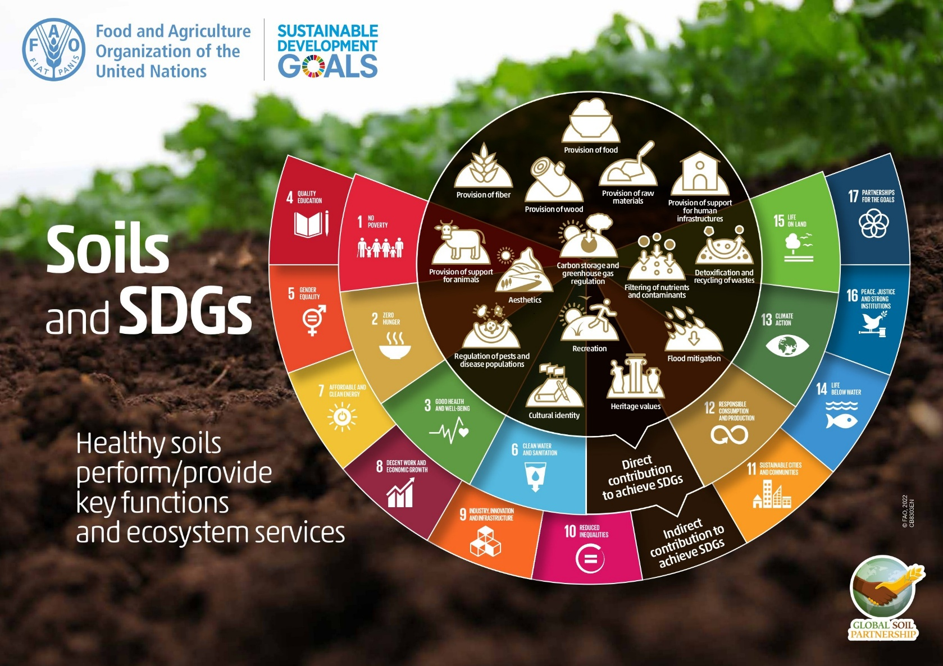

Annex 4 – Laboratory work evaluation rubric
Criteria | 5 - Exemplary | 4 - Proficient | 3 - Satisfactory | 2 - Needs Improvement | 1 - Unsatisfactory
Collaboration | Actively engaged, facilitating group discussions and ensuring all voices are heard. | Participates in group discussions and contributes ideas. | Participates but rarely engages others. | Limited participation, does not encourage collaboration. | Does not participate in group work.
Data Collection | Collects data meticulously, ensuring accuracy and thoroughness. | Collects data accurately with minor errors. | Data collection is basic with some inaccuracies. | Data collection is incomplete or inconsistent. | No data collected.
Analysis and conclusion | Provides in-depth analysis, drawing insightful conclusions based on data. | Analyzes data effectively with logical conclusions. | Basic analysis with some conclusions drawn. | Limited analysis and unclear conclusions. | No analysis or conclusions provided.
Presentation | Presents findings clearly and engagingly. | Presents findings clearly. | Presentation is basic and lacks engagement. | Presentation is unclear and lacks organization. | No presentation provided.

Annex 5 – Student feedback
Students will give feedback on the lessons following an online questionnaire designed for this purpose:
1. Did you know why soil is so important on Earth before this lesson?
□ Yes □ No
2. Did you know factors that affect soil fertility before this lesson?
□ Yes □ No
3. Do you think you now know what they are?
Rate from 1 (I have no idea) to 5 (I know perfectly)
4. Rate the following activities from 1 to 5, depending on whether you found them very interesting (5) or not at all interesting (1)
□ Edafos program
□ Soil and SDGs infographic
□ EarthExplorer
□ Soil sampling
□ Experiments
□ YouTube videos
□ G.I.S. (Google My Maps or Bing Maps)
□ A.I. (Chat GPT and SUNO)
5. Have the contents been presented in an attractive and interactive way?
Rate from 1 (Absolutely not) to 5 (Yes, of course)
6. Has student participation been favoured dynamically?
Rate from 1 (Absolutely not) to 5 (Yes, of course)
7. Do you think that everyone should know about regenerative agriculture?
Rate from 1 (Absolutely not) to 5 (Yes, of course)
8. Do you think what you have learned from this experience is useful?
Rate from 1 (Not useful) to 5 (Very useful)
9. What is the most useful thing you have learned?
10. What could be done to improve this lesson for following years?
11. Have you come across difficulties when carrying out the activities?
If yes, please indicate which ones.

Annex 6 – Teacher feedback rubric
 |  | SELF-ASSESSMENT
GRADE (from 1=Little to 5= A lot) |  | 1 | 2 | 3 | 4 | 5
The objectives are consistent with the learning scenario proposed
ACHIEVEMENT OF OBJECTIVES | Look for useful online information.
ACHIEVEMENT OF OBJECTIVES | Engage students in multidisciplinary activities.
ACHIEVEMENT OF OBJECTIVES | Represent information in G.I.S.
ACHIEVEMENT OF OBJECTIVES | Enrich students’ vocabulary.
ACHIEVEMENT OF OBJECTIVES | Develop critical thinking and to work collaboratively.
ACHIEVEMENT OF OBJECTIVES | Create awareness of soil health and fertility.
CONTENTS | The contents are consistent for the development of skills.
CONTENTS | The presentation of content is done in a motivating way.
CONTENTS | The learning scenario is integrated into the curriculum of the subjects.
ACTIVITIES | Activities promote the achievement of objectives.
ACTIVITIES | Activities follow a logical sequence.
ACTIVITIES | Activities encourage the active participation of students.
ACTIVITIES | The participation of student has been high.
RESOURCES AND TIMES | Material resources have been appropriate.
RESOURCES AND TIMES | Online resources have been appropriate.
RESOURCES AND TIMES | The times envisioned for which activity were sufficient.
Feedback indicators for students are adequate
General satisfaction with this learning scenario

Annex 7 – Experiments
Organic matter
- Take a watch glass or a Petri dish and weigh 10 grams of your soil on it with the help of a scale.
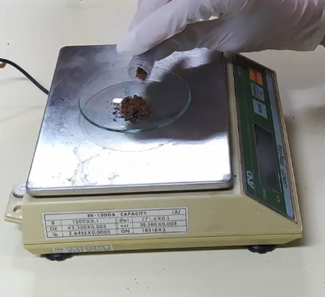
- Add a few drops of hydrogen peroxide to the soil sample.
- If the soil is very organic, effervescence will occur, a fact that does not occur if the soil is poor in organic matter. The chemical reaction that produces effervescence is due to the presence of catalase in the soil. Catalase is an enzyme found in the cells of animal and plant tissues.
- Depending on the bubbling observed, the organic matter content will be determined as: poor (no bubbling), moderate (slight bubbling) or high (intense effervescence and/or foam).
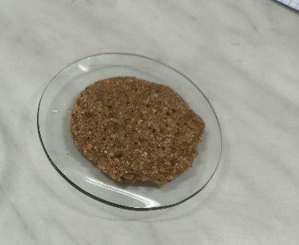
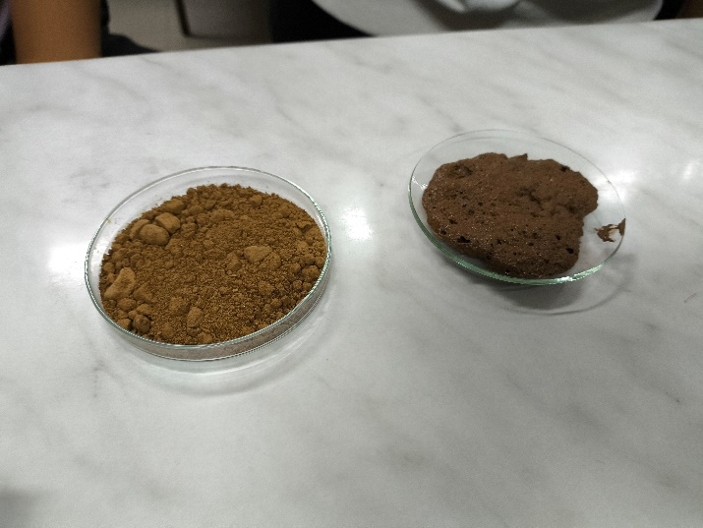
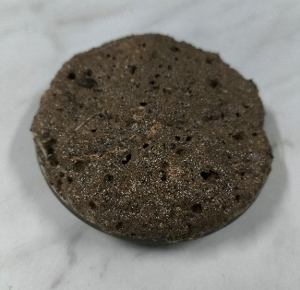
Moisture
Figure 1 Poor (no bubbling)
Figure 2 Moderate (slight bubbling)
Figure 3 High (intense effervescence and/or foam)
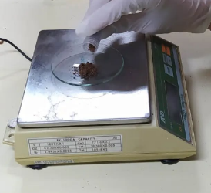
- Take a watch glass or a Petri dish and weigh between 10 and 30 grams of your soil on it with the help of a scale.
- Place the soil sample in the oven or stove at 105 °C for 24 hours.
- Take the soil sample out of the oven or stove, lets it cool, and weighs it again. Calculate the % moisture of their soil using the formula on the data sheet (Annex 2).

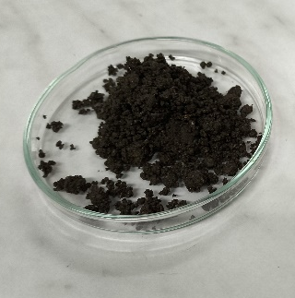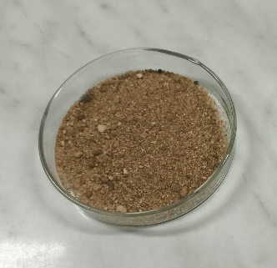
Nutrient retention
- Take a funnel, a beaker and filter paper (conic or a coffee filter). Place the filter paper in the funnel and fill it with soil.
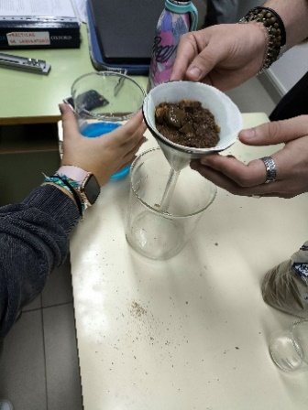

- Add 100 ml of 0.4N copper sulphate CuSO₄ solution.
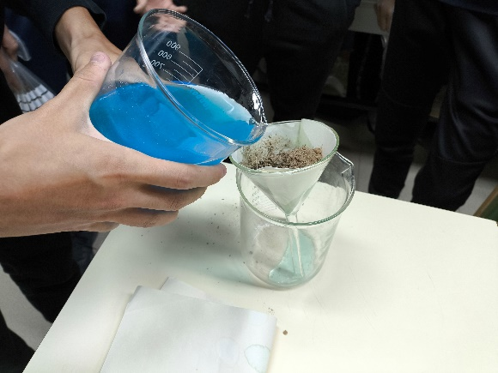

- Observe the colour of the filtered solution. The more transparent it is, it means that it has a greater capacity to retain nutrients. The colour of the solution obtained may vary from the original blue due to its mixture with other chemical elements.
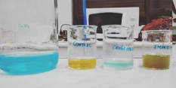

Sustainable Development Goals (SDGs):https://sdgs.un.org/goals

